Feedback System 2022-23
1.4.2 - Feedback process of the Institution is classified as follows:
Feedback is a very crucial part to resolve important decisions in any organization. Hence it is truly indispensable information. The below feedback has innumerous advantages for the students, the professors as well as the principal. It is one of the effective mediums to enhance the administration and academic performance. Feedback process was conducted online by google form with questions. Dharmendrasinhji Arts college took three kinds of feedback during 2022-23. After feedback was collected, they were analyzed and action taken. Feedback is also available on the website.
- Alumni Feedback (2022-23)
- Student Feedback (2022-23)
- Teachers Feedback (2022-23)

The following points are observed through Feedback process:
1. Alumni Feedback (2022-23)

ભૂતપૂર્વ વિદ્યાર્થીઓ પ્રતિસાદ વિશ્લેષણ(2022-23)
82 responses
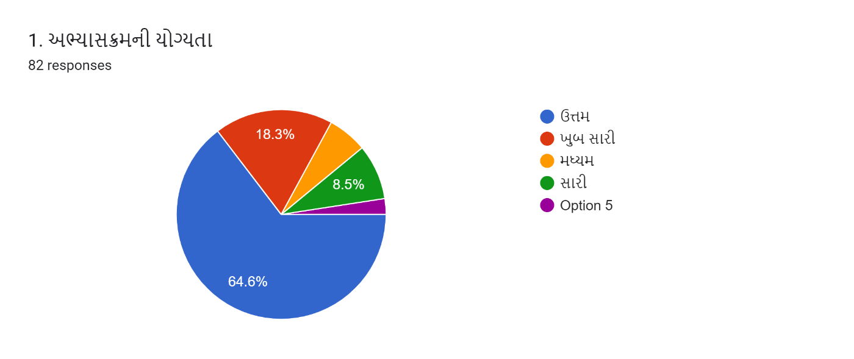
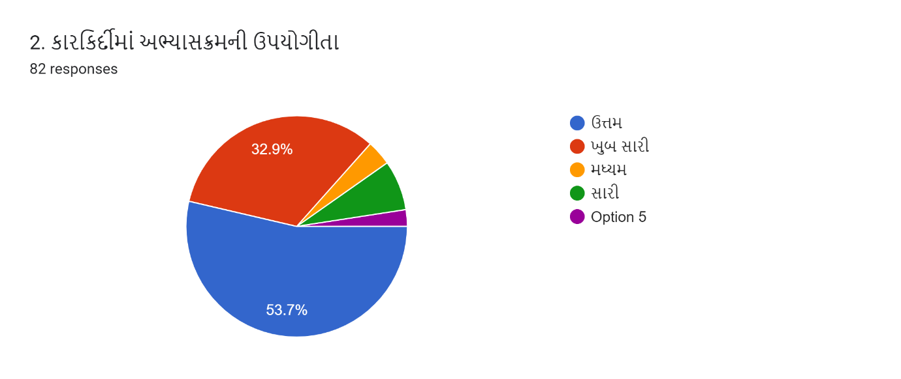

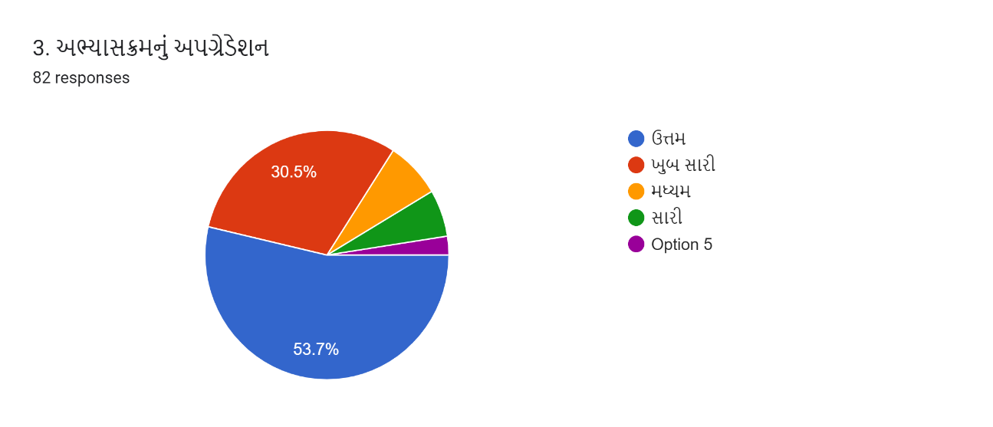Link to S
heets

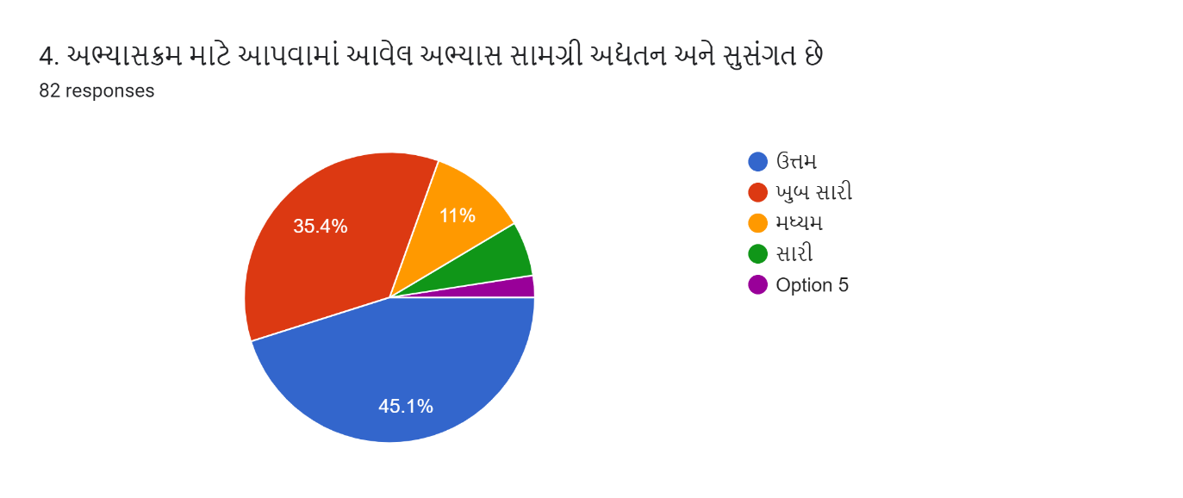
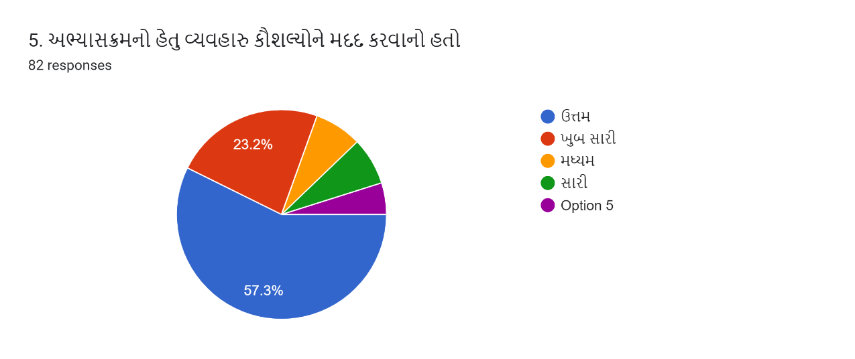
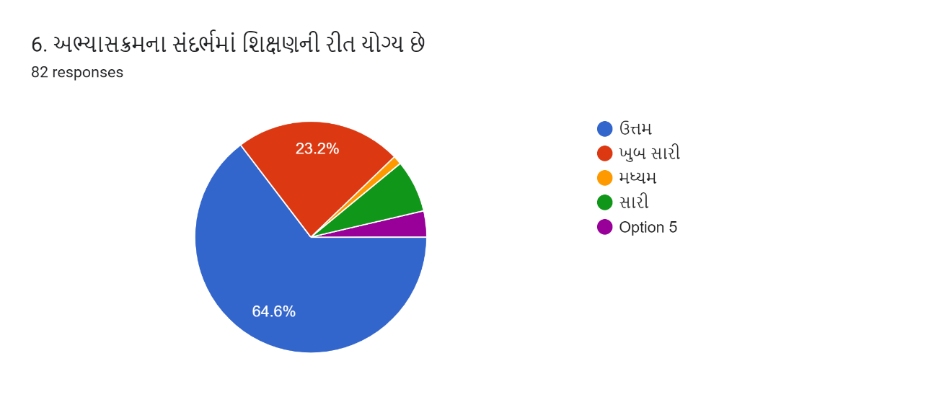
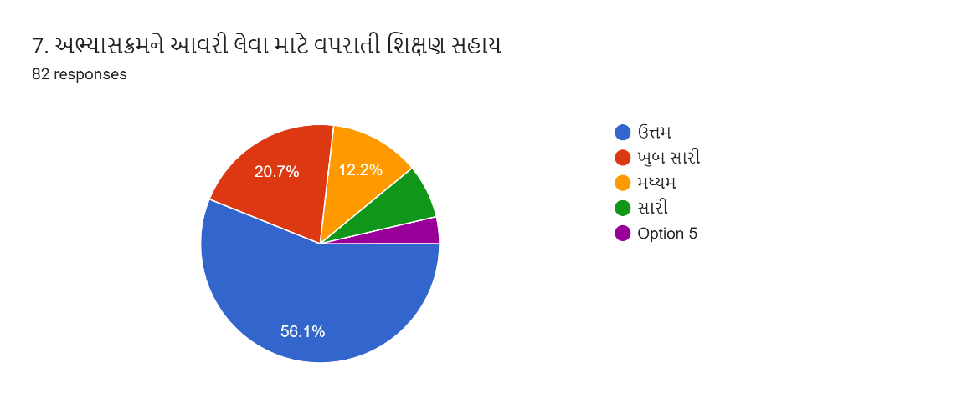

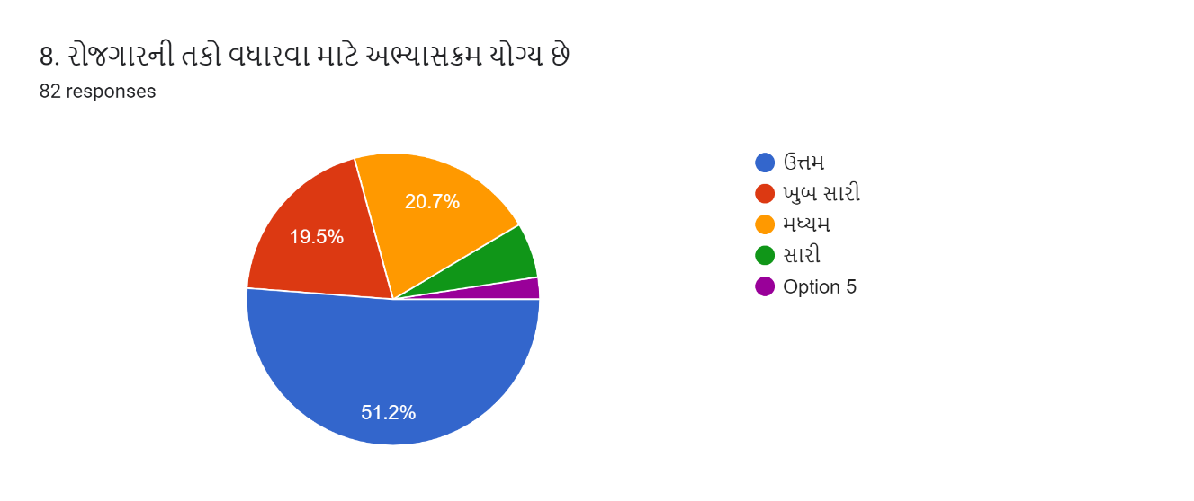

2. Student Feedback (2022-23)

વિદ્યાર્થી પ્રતિસાદ વિશ્લેષણ (2022-23)
149 responses
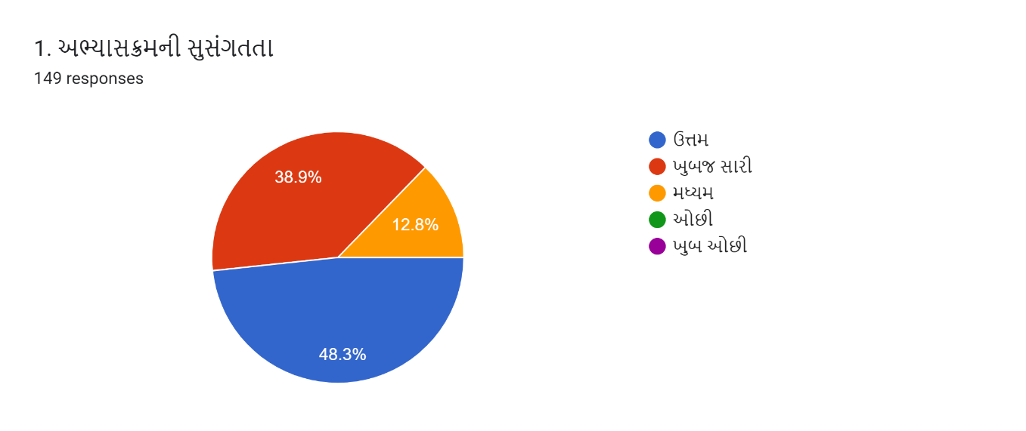
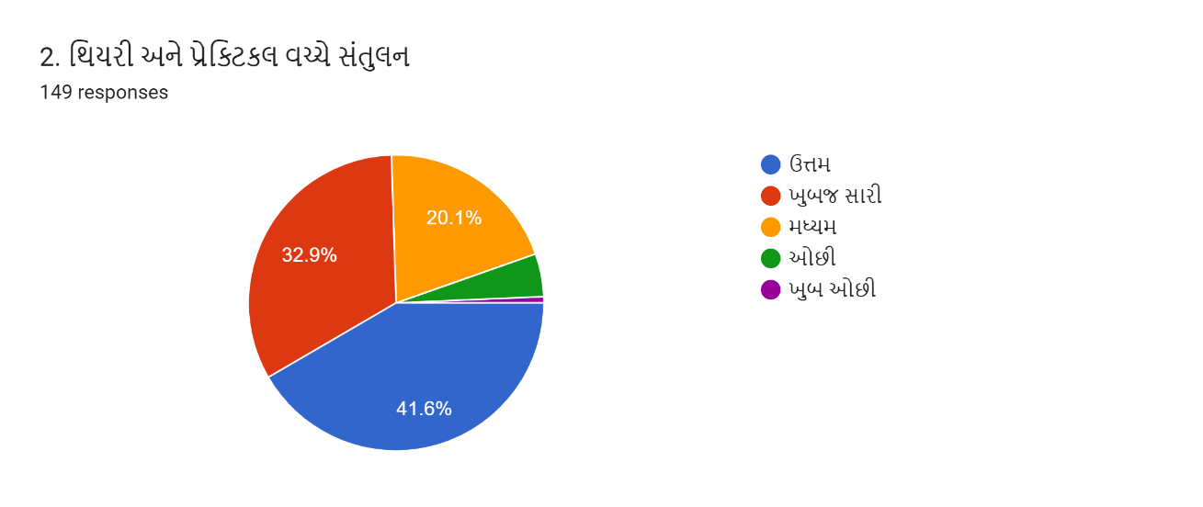
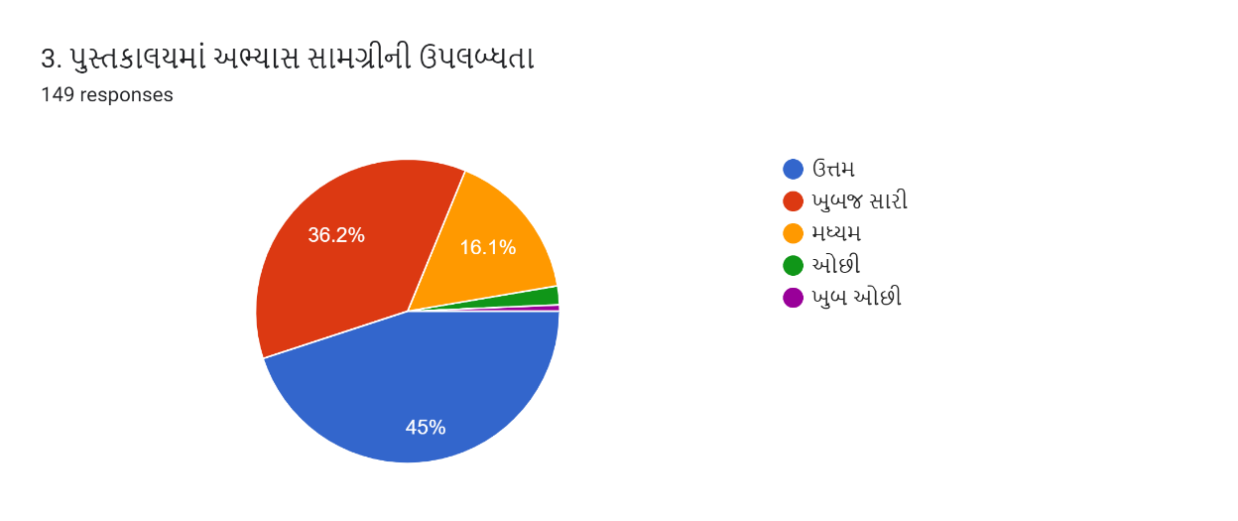

View in Sheets

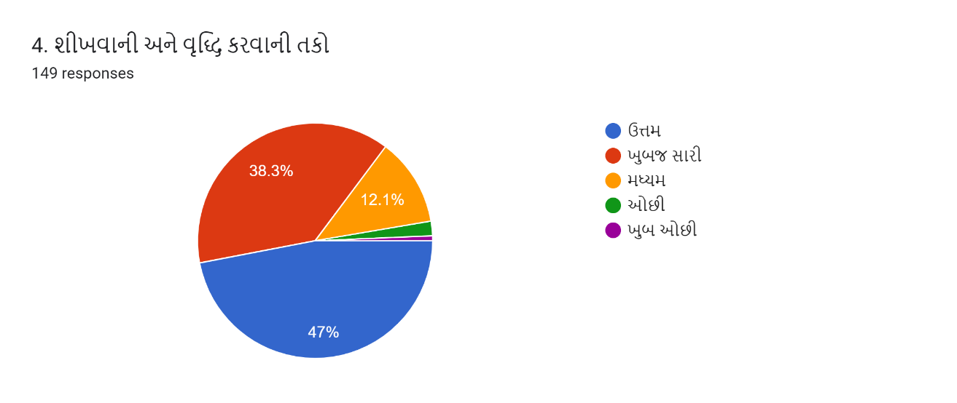

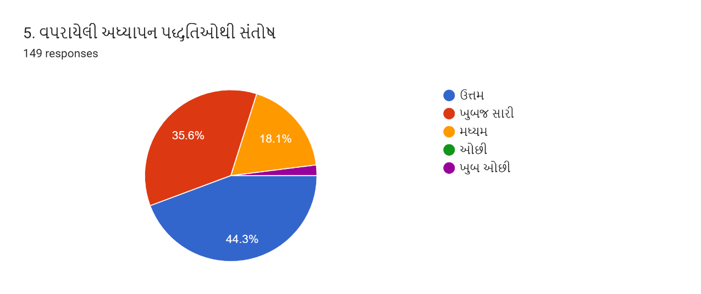
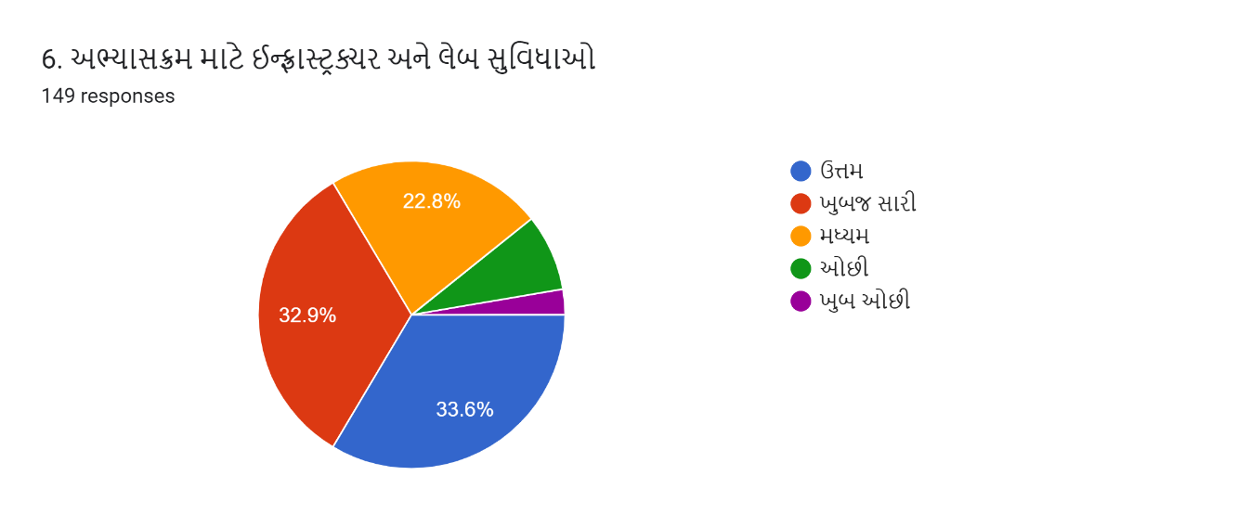

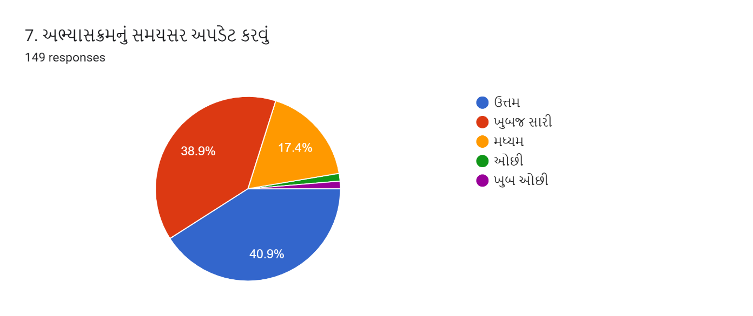
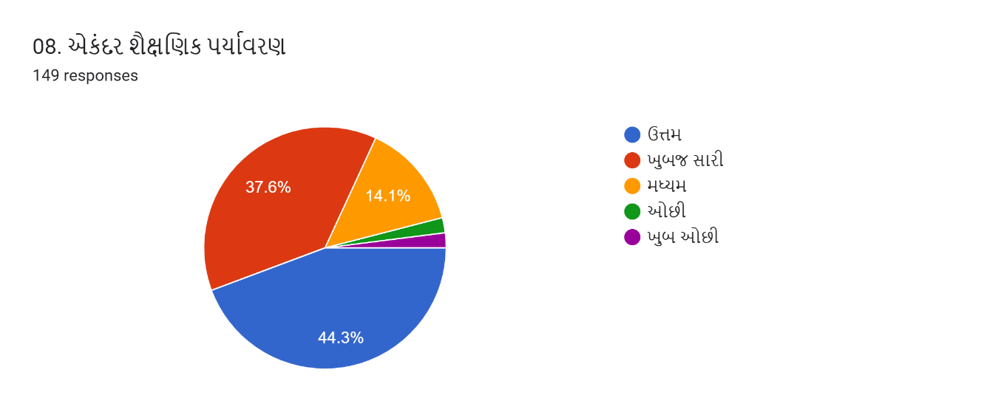

- Teachers Feedback (2022-23)
શિક્ષક પ્રતિસાદ વિશ્લેષણ (2022-23)
